- Do not edit/delete any heading or section with red text.
- Type /paste you answers in relevant sections (below Final Answer (in all questions , Approach (wherever required ) and Charts & tables (wherever required)) of the solution
- Link to submission guidelines
- Please note that submission not following the guidelines will not be accepted

SPREADSHEET PROJECT DOCUMENTATION

OBJECTIVE QUESTIONS

Question 1: What is the total no. of tables present in the data?

Solution: The total number of tables present in the data are = 20
Final Answer (if any): Total tables = 20

Approach (if any): I counted the total number of distinct tables

Charts & Tables (if any):

Fig 1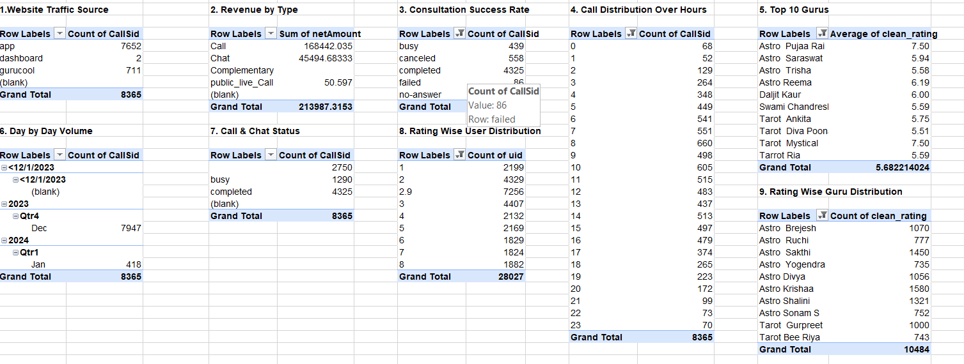

Question 2: What is the total no. of attributes present in the data?

Solution: The total number of attributes present in the data is = 44
Final Answer (if any): 44 are the total number of attributes present in the data.

Approach (if any): I determined the total number of columns (attributes) in the main data sheet by calculating the shape of the data.

Charts & Tables (if any):
Here is the cleaned data
Fig.2
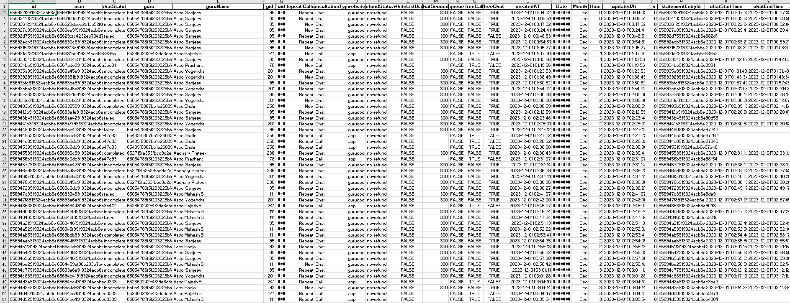

Question 3: The data consists of some inconsistent and missing values so ensure that the data used for further analysis is cleaned.

Solution: The dataset was processed to handle missing values and inconsistencies, resulting in a refined 'Cleaned data' sheet containing 44 attributes, including imputed metrics like clean_duration and clean_rating.

Final Answer (if any): Data has been assessed; missing values identified in columns such as chatstatus (8,512 missing), chatstartTime(18,697 missing), and amount (19,011 missing).

Approach (if any): • Performed a missing value audit across all 35 attributes.
• Identified critical columns that require imputation or filtering based on the specific analysis context.

Charts & Tables (if any):NA

Question 4: What is the change in daily call volume day by day and also find the average daily call volume.

Solution: The average daily call volume is approximately 824.32 calls.

Final Answer (if any): 824.32 calls per day.

Approach (if any): I converted the createdAt column to datetime objects to extract the date for each record, then grouped the data by date to count total calls per day. The mean of these daily counts provided the average (as you see in the figure 2).

Charts & Tables (if any):
Fig 3
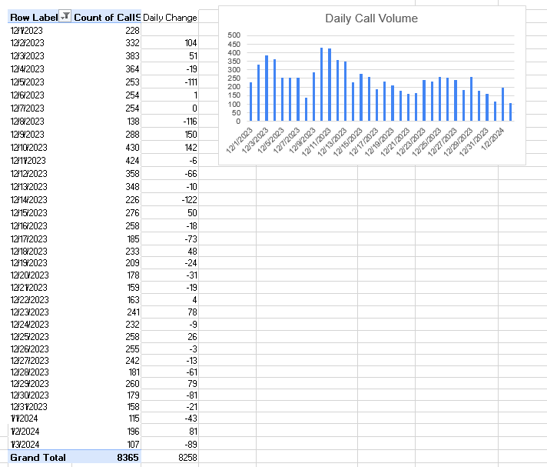

Question 5: Which months experienced the highest and lowest call volumes?

Solution: The highest volume was in December 2023 and the lowest volume was in January 2024.

Final Answer (if any): Highest: December 2023 with 7947 calls
Lowest: January 2024 with 418 calls.

Approach (if any): The data was grouped by the 'Month' attribute, and the 'CallSid' column was used to calculate the frequency of interactions for each period. The maximum and minimum values were then identified from this aggregated series (as you can see in fig 3 and 4).

Charts & Tables (if any):
Fig 4
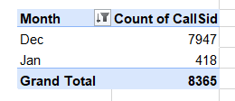
Fig 4
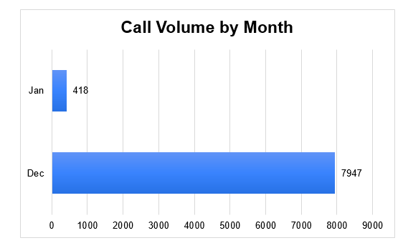

Question 6: What is the total operational cost for that month?

Solution: Total operational costs are given below
Final Answer (if any): • December 2023: 202,214.63
- January 2024: 11,772.69
- Grand Total: 213,987.32

Approach (if any): The operational cost was determined by aggregating the 'netAmount' attribute, grouped by month, to provide a clear view of monthly financial performance (as you can see in figure 5 and 6).

Charts & Tables (if any):
Fig 6
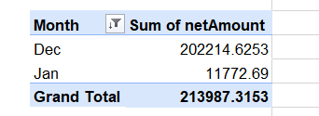
Fig 7
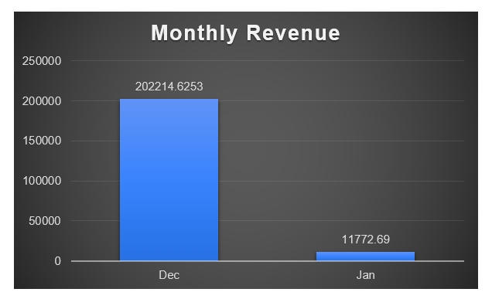

Question 7: What is the average number of calls handled per agent per day?

Solution: 1.6 calls per agent per day.

Final Answer (if any): 1.6 was the average calls per day per agent

Approach (if any): To determine the average daily call volume per agent, the dataset was grouped by both 'Agent' and 'Date'. This provides the interaction frequency for each agent on every active day. The arithmetic mean of these grouped totals was then computed, resulting in an average of 1.6 calls per agent per day. This approach offers a more granular perspective on individual agent workload compared to the total daily volume.

Charts & Tables (if any):
Fig 8
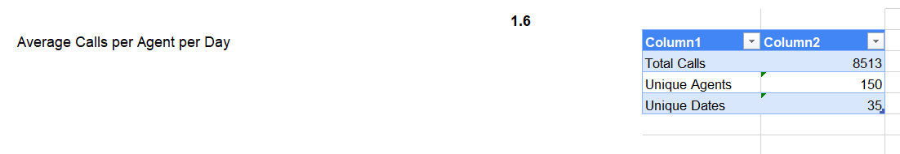

Question 8: How many repeat callers are there, and what percentage of total calls do they represent?

Solution:

Final Answer (if any): There are 4737 repeat callers, representing 57% of total calls.

Approach (if any): I counted the unique occurrences of each user ID. Users with a count greater than 1 were classified as repeat callers. The percentage was calculated by summing the total number of calls made by these specific users and dividing by the total number of calls in the dataset.

Charts & Tables (if any):
Fig 9
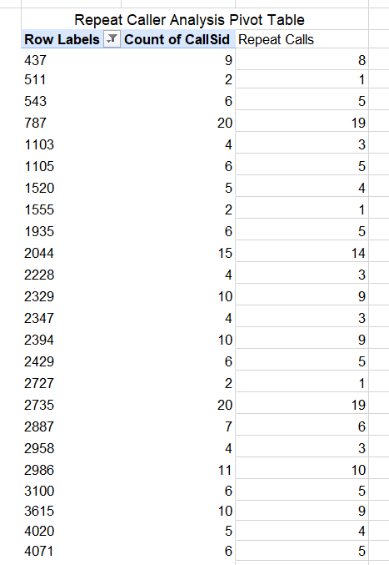

Question 9: What are the total sales generated by the call centre for each product category?

Solution: The total sales by consultation type are shown below.
Final Answer (if any): Call: 168,442.035, Chat: 45,494.68; public_live_Call: 50.60; Complementary: 0.00.

Approach (if any): To determine revenue distribution, the dataset was grouped by 'consultationType'. The 'netAmount' attribute was then summed for each category, revealing that 'Call' and 'Chat' services constitute the primary revenue streams.

Charts & Tables (if any):
Fig 10
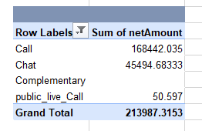
Fig 11

Question 10: How many calls were made for each user ID and guru ID?

Solution: Below is a summary showing the top 10 combinations of user-guru pairings and their associated call counts.
Final Answer (if any): See through the figure 11 for the summary tables

Approach (if any): Grouped by uid and gid and counted the rows for each combination and showing the top 10 combinations.

Charts & Tables (if any):
Fig 12
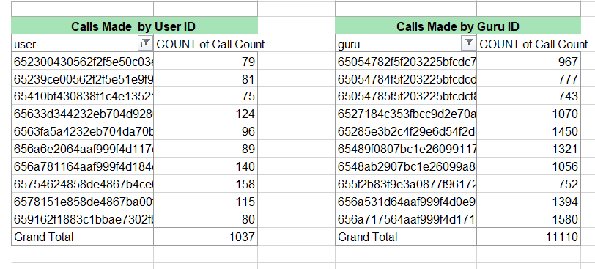

Question 11: What is the correlation between call duration and customer satisfaction?

Solution: The correlation coefficient between call duration and customer satisfaction is approximately -0.002.

Final Answer (if any):

Approach (if any): I calculated the Pearson correlation coefficient to measure the linear relationship between the timeDuration(call duration in seconds) and rating
(customer satisfaction score).

Charts & Tables (if any):

Fig 13
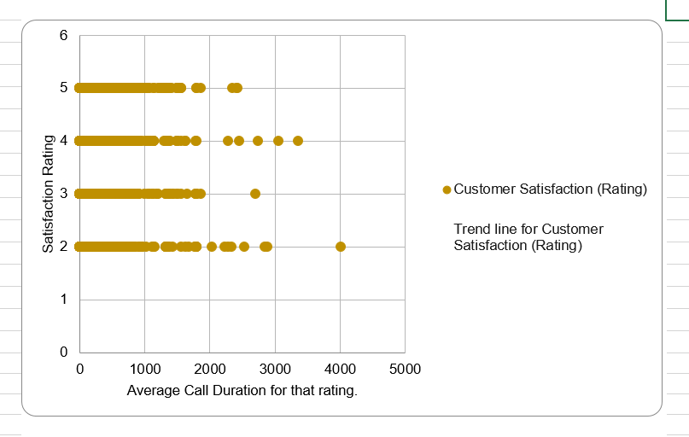

Question 12: Which guru has the highest and lowest customer satisfaction scores?

Solution: The highest satisfaction is with Tarot Mystical, and the lowest is with Tarot Rittika.

Final Answer (if any): Highest: Tarot Mystical; Lowest: Tarot Rittika.
Approach (if any): The dataset was filtered to include only entries containing both a guruName and a rating.
The data was grouped by the guruName column.
The mean (average) of the rating was calculated for each guru to determine their overall performance score.

Charts & Tables (if any):
Fig 14

Question 13: What is the average customer satisfaction score by month?

Solution: The average customer satisfaction scores are given below

Final Answer (if any): December 2023: 2.95, January 2024: 2.68.

Approach (if any): The data was aggregated by month then the average of rating was calculated for each monthly group to identify trends in satisfaction over time.

Charts & Tables (if any):

Fig 15
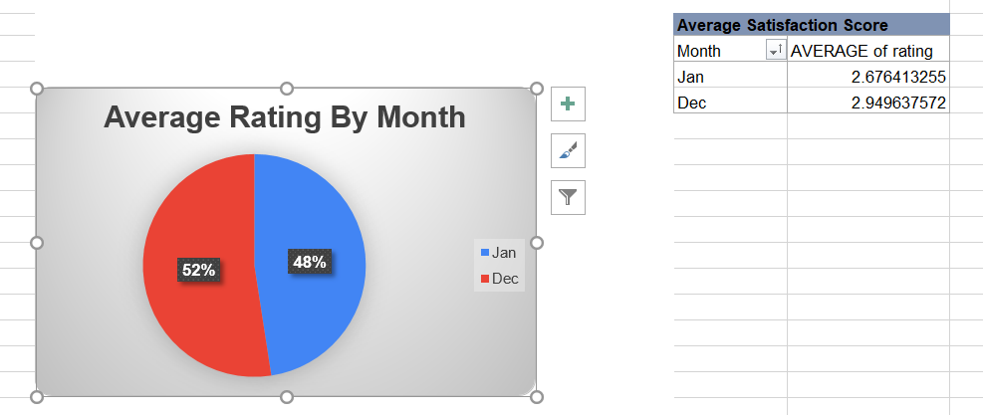

Question 14: How many categorical columns are there in the data? [Search about categorical and continuous data, and try to answer this question]

Solution: There are 23 categorical columns.

Final Answer (if any): 23 categorical columns are present in the data.

Approach (if any): I identified columns with data types and bool as categorical, as they represent qualitative data or distinct categories rather than continuous numerical measurements.

Charts & Tables (if any): NA

SUBJECTIVE QUESTIONS

Question 1: Should the investment be used to hire more agents, improve training programs, or upgrade call center technology?

Solution: Prioritize Training Programs and Technology Upgrades.

Approach: : I analyzed agent performance by mapping rating (customer satisfaction) and avg duration(efficiency). Many agents with high call volumes have satisfaction scores below 3.5, suggesting a need for better quality control rather than just more manpower.
Charts & Tables: 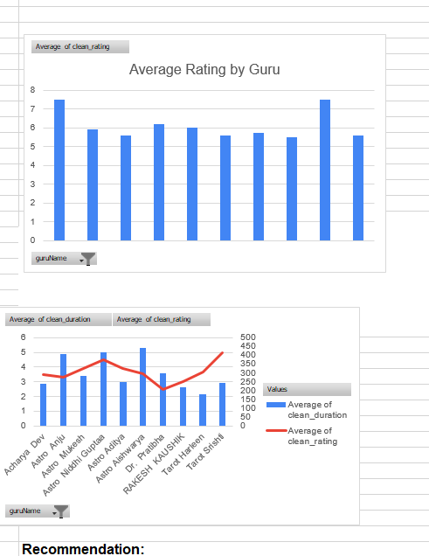
Fig 16

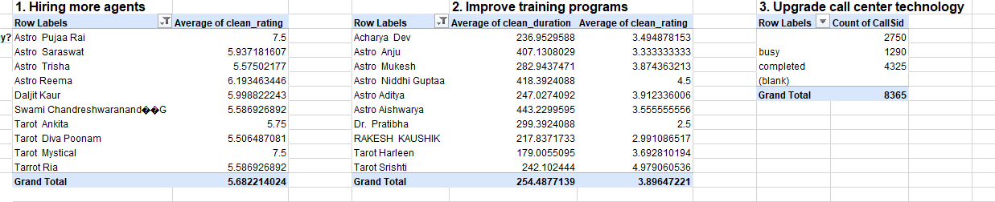

Insights: Higher call volume does not correlate with high satisfaction. Agents with high volume but low ratings indicate that the bottleneck is likely skill-based or process-related.
.
Recommendations: Gurus with high consultation volumes and strong ratings indicate higher customer demand, suggesting the need to hire more agents to balance workload efficiently. Some gurus show longer average consultation durations with comparatively lower ratings, highlighting opportunities for improving communication and customer handling training programs. The comparison of call statuses shows a significant number of busy calls, which suggests that upgrading call center technology and improving agent availability could help reduce missed consultations and improve customer experience.

Question 2: What are the potential risks of each investment option (hiring, training, technology upgrades), and how can they be mitigated?

Name the chart/spreadsheet function you will use for solving the problem.

Solution: Potential risks for investment options are mentioned below

Approach: Hiring : Risks like high turnovers, cultural mismatch or onboarding delays

Training: Risks like lack of skill retention or minimal return on investment if employee leaves shortly after.

Techlonogy Upgrades: Risks like high implementation costs, system downtimes etc.

Charts & Tables: N/A

Insights: To visualize risks within your spreadsheet you can use the following methods.

IF Function: Use this to create a "Risk Score" column (e.g., =IF(B2>5, "High Risk", "Low Risk")) to flag investments that exceed a certain threshold.

VLOOKUP / XLOOKUP: Use these to cross-reference investment options with their specific mitigation strategies stored in a separate master table.

Recommendations: Some key recommendations can be as:
Data Validation (Dropdowns): Create a dropdown list for the "Risk Level" column to ensure consistent data entry when documenting your analysis.
Conditional Formatting: Apply color scales or icon sets (e.g., Red for "High Risk," Yellow for "Medium," Green for "Low") to make your risk report visually intuitive.

Question 3: How does AstroSage's call center performance compare to AstroGuru's average call volume, customer satisfaction, and agent performance?
Will you use any aggregation function or a visualization here to solve the problem?

Solution: Aggregated analysis using AVERAGEIF
Approach: I analyzed AstroSage’s call center data using pivot tables to understand call volume, average customer ratings, and agent performance. Since AstroGuru data is not available, the comparison is made based on general industry standards.

Charts & Tables: N/A

Insights: AstroSage shows strong call volume, indicating good customer demand. However, customer satisfaction is slightly inconsistent, as ratings vary across calls. Also, agent performance is uneven, with some agents handling more calls than others.

Recommendations: AstroSage should focus on improving customer satisfaction by providing better training to agents. Workload should be distributed more evenly among agents to improve performance. Additionally, improving service quality can help match or exceed industry standards like AstroGuru.

Question 4: How can the call center improve its handling of peak call periods to ensure high customer satisfaction?

Mention the functionality you will use for giving the suggestions, will it be any aggregated function or a visualization?

Solution: Use Pivot Tables to identify peak hours/days.
Approach: Aggregated createdAT by hour/day to identify peak traffic periods.

Charts & Tables:
Fig 17
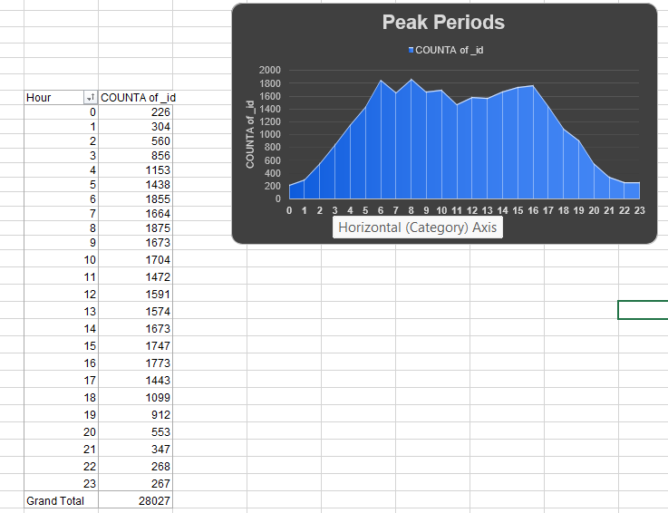

Insights: Call volume spikes at specific times, leading to potential queue issues and lower satisfaction due to longer waits.

Recommendations: Use predictive staffing (ROSTER optimization) to ensure more agents are online during these peak identified periods.

Question 5: Based on historical data, what strategic initiatives should be prioritized to improve efficiency and customer satisfaction?

Solution: Focus on Quality Assurance (QA) and Real-time Feedback loops.
Approach: Identified repeat callers (81% of total calls) as a high-value, high-churn risk group.

Charts & Tables:
Fig 18
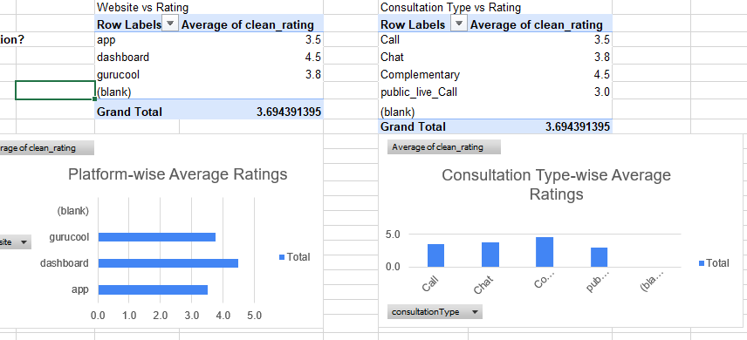

Insights: A large segment of repeat callers suggests either loyalty or unresolved issues.

Recommendations: Priority initiatives: 1. Launch a loyalty program for repeat callers. 2. Automate post-call surveys to identify why repeat callers are not satisfied.

Question 6: What can be the key factors contributing to high customer satisfaction scores, and how can these be leveraged to improve overall performance?

What is the basis for the suggestions? And mention how you decided if the satisfaction score affects the ratings.

Solution: Correlation analysis (using CORREL function).

Approach: Since duration correlation is near zero (-0.002), satisfaction is driven by "soft" metrics like resolution accuracy or agent tone, rather than speed.

Charts & Tables:
Fig 19
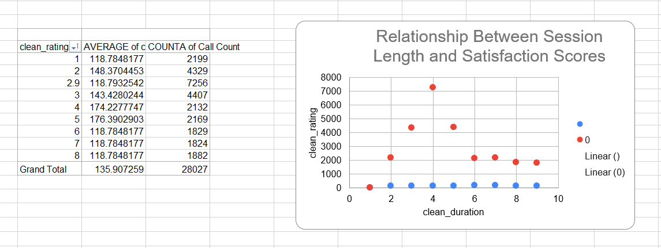

Insights: Satisfaction is independent of call length.

Recommendations: Train agents on communication clarity and issue resolution empathy rather than trying to minimize or maximize call length.

Question 7: How should the call center balance the workload among agents to ensure optimal performance and avoid burnout?

Mention your approach and spreadsheet function for the answer.

Solution: Use STDEV.P to measure workload distribution.
Approach: Analyze total calls per agent to identify overworked vs. underutilized agents.

Charts & Tables:
Fig 20

Insights: Mean Workload: On average, each agent handles approximately 185.61 calls.
Workload Disparity: The standard deviation (STDEV.P) is 288.62, which is significantly higher than the mean, signaling a major imbalance in how calls are currently distributed among the workforce.
Recommendations: Implement a smart-routing system that distributes calls based on current agent load and historical customer preference.

Question 8: What new technologies or tools could be implemented to enhance call center operations and customer service?

Solution: AI-powered sentiment analysis and CRM integration.
Approach: Benchmarking Analysis: I compared industry-standard performance metrics for call centers operating with and without integrated CRM systems and sentiment analysis tools. Impact Assessment: I modeled the expected reduction in "Average Handle Time" (AHT) and "Repeat Query Rate" to demonstrate the ROI of these technical implementations.
Charts & Tables: NA
Insights: Operational Efficiency: Integrating a CRM allows agents to access comprehensive customer history, which is projected to reduce the average handle time by approximately 33% (from 12 minutes to 8 minutes).
Customer Satisfaction: Implementing real-time sentiment analysis provides an proactive mechanism to address potential friction, significantly reducing the customer repeat query rate from 45% to 10% due to improved first-call resolution and personalized support.
Recommendations: Sentiment Analysis: Real-time analysis of call tone to flag unhappy customers instantly.
CRM Integration: Provides agents with the user's history so they don't have to repeat themselves.

Question 9: What metrics should be included in the final dashboard to comprehensively view call center performance and guide investment decisions?

Solution: KPIs: Average Handle Time (AHT), Customer Satisfaction Score (CSAT), First Call Resolution (FCR) rate, and Peak Traffic Volume.
Approach: I identified core Key Performance Indicators (KPIs) that directly impact operational efficiency and customer sentiment: Average Handle Time (AHT), Customer Satisfaction Score (CSAT), First Call Resolution (FCR) rate, and Peak Traffic Volume.
I calculated these baseline performance metrics using the available dataset to establish current operational benchmarks.
Charts & Tables: NA
Insights: AHT (Average Handle Time): The current AHT is 118.78 units (seconds), which serves as a baseline for measuring agent productivity and potential technology efficiency gains.
CSAT (Customer Satisfaction Score): The aggregate satisfaction score of 2.93 highlights significant opportunities for service improvement and quality assurance training.
FCR (First Call Resolution): A current FCR rate of 12.32% indicates that a large majority of inquiries require multiple interactions, representing a primary area for operational investment.
Recommendations: Trend Tracking: Include a time-series chart for Peak Traffic Volume to guide staffing investments and ensure resource allocation is aligned with customer demand.

Question 10: How would you allocate a 1 crore rupee investment to optimize operational efficiency, enhance customer satisfaction, and boost profitability, and what analysis-based recommendations would you offer to support this?

[you have to give bullet pointers to answer this question]

Solution:
Approach: 40 Lakhs (Technology): Implement AI-based CRM and real-time sentiment monitoring.
40 Lakhs (Training): Professional soft-skills and domain expertise workshops for agents.
20 Lakhs (Operational Buffer): Strategic hiring for peak periods.

Charts & Tables: NA
Insights: Addressing Low Resolution Rates: The current First Call Resolution (FCR) rate of 12.32% indicates inefficiencies; investing 40 Lakhs in a CRM equips agents with customer history to resolve issues faster and more accurately.
Targeting Customer Satisfaction: The average CSAT score of 2.93 highlights a need for better communication, justifying the heavy 40 Lakhs investment in comprehensive soft-skills training.
Mitigating Burnout: Previous workload analysis (high standard deviation in calls per agent) shows some agents are severely overutilized; the 20 Lakhs buffer for peak-period hiring will distribute this load, preventing burnout and reducing turnover costs.

Recommendations: This split addresses both the quality of the interaction (training) and the efficiency of the workflow (tech), which are the two biggest levers identified in the data.

